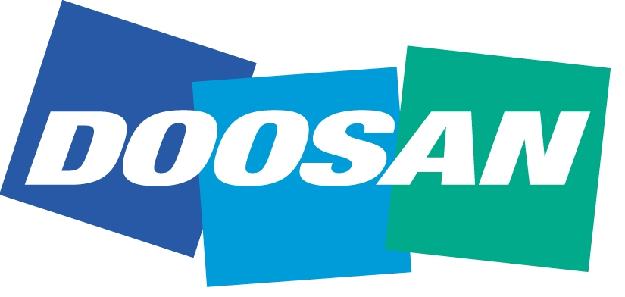
We aspire to be a Proud Global Doosan – a leading innovator of products and services that improve the quality of life for people and communities around the world.
Dear Reader,
Founded over 110 years ago, Doosan employs over 42,000 people in 39 different countries and has annual revenues in excess of US $21.6-billion, making it one of the largest and growing corporations in the world.
Doosan’s strength comes from its vast array of products and services ranging from power generation and desalination to major construction projects, engines, military equipment, construction equipment and industrial forklifts. As well as building high-rise luxury apartments, major highways and power generation, Doosan also boasts its own 5-star Ladena hotel resort and golf complex, a global advertising agency and a Professional baseball team – the Doosan Bears.
Our impressive headquarters in the South Korean capital city of Seoul, the Doosan tower is one of the most well-known landmarks, welcoming over 100,000 visitors per day and housing almost 600 shops over 8 floors, is extremely popular with the fashion shoppers.
Doosan Industrial Vehicles is committed to innovation, the advancement of new technologies and development of talented individuals, positioning us to respond effectively to the rapid changes in the global market place. We are already in the Top 5 manufacturers in the UK, and we aim to be one of the top manufacturers in the world and are well on our way to achieving our goal. We are continuously growing our market share in all corners of the globe and we believe we have the best value forklifts on the market today.
Following our recent acquisition of the UK’s leading independent service and fleet management company, Rushlift Ltd, our aim is to develop our direct route to market in the national accounts and larger fleet sectors to continue growing our market share. We already have some great partners, dealers and customers promoting and using our ever-growing product range and we want to give them an even better service by investing in additional people and their expertise.
People are at the core of Doosan’s philosophy and by helping our people to develop their skills and to grow as individuals, we believe that we will continue our growth and become an even stronger company.
If you are hard-working, dynamic, and creative and you want to be part of a growing successful team, then we want to hear from you!
Kind regards
Paul Watson
UK Sales Director
Doosan Industrial Vehicle UK Ltd

